|  |  |
| --- | --- |
| **Ex.** 2 | **UNITS CONVERTERS** |
| **Date:** 26-07-2024 | |

**AIM:**

To develop a Java application that converts different units and currencies.

**ALGORITHM:**

1. Create different classes for each converter and define the members of the classes and the methods used.
2. Create a main class which creates objects in order to access the members of the other classes.
3. Receive the inputs from the user during the runtime.
4. Compute the conversion based on the unit or currency.
5. Display the converted value.

**PROGRAM:**

// Class for Currency Converter

package Java.Lab2;

public class currencyConverter {

// Constant Factors

private static final double dollarToINRFactor = 83.72;

private static final double INRToDollarFactor = 0.012;

private static final double euroToINRFactor = 90.96;

private static final double INRToEuroFactor = 0.011;

private static final double yenToINRFactor = 0.55;

private static final double INRToYenFactor = 1.83;

// Methods defined in the Class

public double dollarToINR(double dollar)

{

double INR = dollar * dollarToINRFactor;

return INR;

}

public double INRToDollar(double INR)

{

double dollar = INR * INRToDollarFactor;

return dollar;

}

public double euroToINR(double euro)

{

double INR = euro * euroToINRFactor;

return INR;

}

public double INRtoEuro(double INR)

{

double euro = INR * INRToEuroFactor;

return euro;

}

public double yenToINR(double yen)

{

double INR = yen * yenToINRFactor;

return INR;

}

public double INRToYen(double INR)

{

double yen = INR * INRToYenFactor;

return yen;

}

}

// Class for Distance Converter

package Java.Lab2;

public class distanceConverter {

    // Constant Factors

    private static final double milesToKilometerFactor = 1.609;

    private static final double kilometerToMilesFactor = 0.621;

    // Methods defined in the Class

    public double milesToKilometer(double miles)

    {

        double km = miles * milesToKilometerFactor;

        return km;

    }

    public double kilometerToMiles(double km)

    {

        double miles = km * kilometerToMilesFactor;

        return miles;

    }

}

// Class for Time Converter

package Java.Lab2;

public class timeConverter {

    // Constant Factors

    private static final double hoursToMinutesFactor = 60;

    private static final double minutesToHourFactor = 0.0167;

    private static final double minutesToSecondsFactor = 60;

    private static final double secondsToMinutesFactor = 0.0167;

    private static final double hoursToSecondsFactor = 3600;

    private static final double secondsToHoursFactor = 0.000278;

    // Methods defined in the Class

    public double hoursToMinutes(double hours)

    {

        return hours * hoursToMinutesFactor;

    }

    public double minutesToHours(double minutes)

    {

        return minutes * minutesToHourFactor;

    }

    public double minutesToSeconds(double minutes)

    {

        return minutes * minutesToSecondsFactor;

    }

    public double secondsToMinutes(double seconds)

    {

        return seconds * secondsToMinutesFactor;

    }

    public double hoursToSeconds(double hours)

    {

        return hours * hoursToSecondsFactor;

    }

    public double secondsToHours(double seconds)

    {

        return seconds * secondsToHoursFactor;

    }

}

// Main Class

package Java.Lab2;

// Importing the other classes

import Java.Lab2.distanceConverter;

import Java.Lab2.currencyConverter;

import Java.Lab2.timeConverter;

import java.util.Scanner;

public class lab2 {

    public static void main(String[] args) {

        int choice;

        int subChoice;

        double value;

        boolean loopController = true;

        Scanner input = new Scanner(System.in);

        // Menu Driven Program

        while(loopController)

        {

            System.out.println("Hello!");

            System.out.println("Enter the Serial Number for the Converter Required :");

            System.out.println("1. Distance Converter.");

            System.out.println("2. Currency Converter.");

            System.out.println("3. Time Converter.");

            System.out.println("4. Exit.");

            choice = input.nextInt();

            switch (choice) {

                case 1:

                    distanceConverter objDistance = new distanceConverter();

                    System.out.println("Enter the Serial Number for the Type of Conversion : ");

                    System.out.println("1. Miles to Kilometers.");

                    System.out.println("2. Kilometers to Miles.");

                    subChoice = input.nextInt();

                    switch (subChoice) {

                        case 1:

                            System.out.println("Enter the number of Miles : ");

                            value = input.nextDouble();

                            System.out.println("Kilometers = "+objDistance.milesToKilometer(value));

                            break;

                        case 2:

                            System.out.println("Enter the number of Kilometers : ");

                            value = input.nextDouble();

                            System.out.println("Miles = "+objDistance.kilometerToMiles(value));

                            break;

                        default:

                            System.out.println("Invalid Input.");

                            break;

                    }

                    break;

                case 2:

                    currencyConverter objCurrency = new currencyConverter();

                    System.out.println("Enter the Serial Number for the Type of Conversion : ");

                    System.out.println("1. INR to Dollars.");

                    System.out.println("2. Dollars to INR.");

                    System.out.println("3. INR to Euro.");

                    System.out.println("4. Euro to INR.");

                    System.out.println("5. INR to Yen.");

                    System.out.println("6. Yen to INR.");

                    subChoice = input.nextInt();

                    switch (subChoice) {

                        case 1:

                            System.out.println("Enter the number of INR : ");

                            value = input.nextDouble();

                            System.out.println("Dollars = "+objCurrency.INRToDollar(value));

                            break;

                        case 2:

                            System.out.println("Enter the number of Dollars : ");

                            value = input.nextDouble();

                            System.out.println("INR = "+objCurrency.dollarToINR(value));

                            break;

                        case 3:

                            System.out.println("Enter the number of INR : ");

                            value = input.nextDouble();

                            System.out.println("Euro = "+objCurrency.INRtoEuro(value));

                            break;

                        case 4:

                            System.out.println("Enter the number of Euro : ");

                            value = input.nextDouble();

                            System.out.println("INR = "+objCurrency.euroToINR(value));

                            break;

                        case 5:

                            System.out.println("Enter the number of INR : ");

                            value = input.nextDouble();

                            System.out.println("Yen = "+objCurrency.INRToYen(value));

                            break;

                        case 6:

                            System.out.println("Enter the number of Yen : ");

                            value = input.nextDouble();

                            System.out.println("INR = "+objCurrency.yenToINR(value));

                            break;

                        default:

                            System.out.println("Invalid Input.");

                            break;

                    }

                    break;

                case 3:

                    timeConverter objTime = new timeConverter();

                    System.out.println("Enter the Serial Number for the Type of Conversion : ");

                    System.out.println("1. Hours to Minutes.");

                    System.out.println("2. Minutes to Hours.");

                    System.out.println("3. Minutes to Seconds.");

                    System.out.println("4. Seconds to Minutes.");

                    System.out.println("5. Hours to Seconds");

                    System.out.println("6. Seconds to Hours.");

                    subChoice = input.nextInt();

                    switch (subChoice) {

                        case 1:

                            System.out.println("Enter the number of Hours : ");

                            value = input.nextDouble();

                            System.out.println("Minutes = "+objTime.hoursToMinutes(value));

                            break;

                        case 2:

                            System.out.println("Enter the number of Minutes : ");

                            value = input.nextDouble();

                            System.out.println("Hours = "+objTime.minutesToHours(value));

                            break;

                        case 3:

                            System.out.println("Enter the number of Minutes : ");

                            value = input.nextDouble();

                            System.out.println("Seconds = "+objTime.minutesToSeconds(value));

                            break;

                        case 4:

                            System.out.println("Enter the number of Seconds : ");

                            value = input.nextDouble();

                            System.out.println("Minutes = "+objTime.secondsToMinutes(value));

                            break;

                        case 5:

                            System.out.println("Enter the number of Hours : ");

                            value = input.nextDouble();

                            System.out.println("Seconds = "+objTime.hoursToSeconds(value));

                            break;

                        case 6:

                            System.out.println("Enter the number of Seconds : ");

                            value = input.nextDouble();

                            System.out.println("Hours = "+objTime.secondsToHours(value));

                            break;

                        default:

                            System.err.println("Invalid Input.");

                            break;

                    }

                    break;

                case 4:

                    System.err.println("Exiting...");

                    loopController = false;

                    break;

                default:

                    System.out.println("Invalid Input.");

                    break;

            }

        }

    }

}

**OUTPUT:**

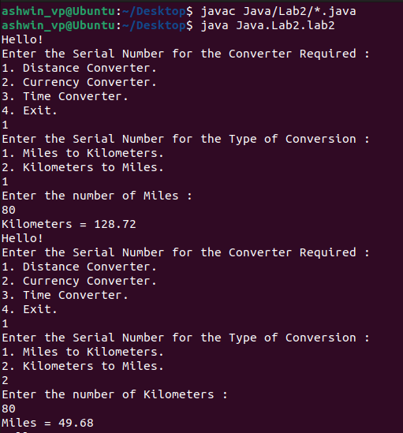

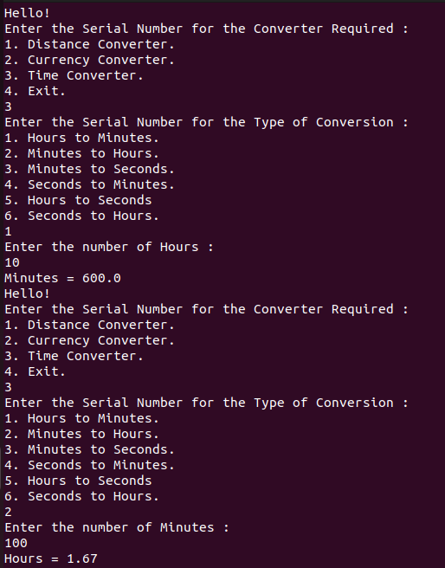

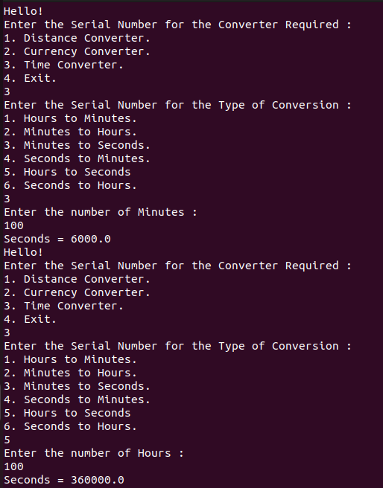

**RESULT:**

Thus, a Java application to calculate and display the electricity bill for a consumer based on the type of EB connection (domestic or commercial) and the number of units consumed is successfully created.